**Technical Document for Personal Task Manager Prototype**

**Website: https://infost790s1.uwmsois.com/**

**Introduction:**

This technical document describes the development of a personal task manager prototype, which is a web-based application developed to help users manage their daily tasks and events. The system was developed using modern web development tools and technologies, including HTML and CSS. The goal of this document is to provide a comprehensive understanding of the system's architecture, design, and functionality.

**System Architecture:**

The system architecture is designed as a client-server model, where the client is the web browser, and the server is a PHP server. The web pages are developed using HTML, CSS, and JavaScript, which are then executed by the browser. The browser communicates with the server using HTTP requests, and the server sends back the requested data as an HTTP response.

**System Design:**

The system's design is based on a Model-View-Controller (MVC) architecture, which separates the system into three components: the Model, the View, and the Controller. The Model component represents the data and business logic of the system, the View component is responsible for rendering the user interface, and the Controller component handles user input and interacts with the Model and View components.

**System Functionality:**

The system provides users with the ability to create, edit, and delete tasks and events, which can be organized by date and time. The system also allows users to set task priorities, and due dates. The user interface is designed to be intuitive and easy to use, with drag-and-drop functionality for rearranging tasks and events. Additionally, the system includes a search function that allows users to search for specific tasks and events.

**Functionality:**

The Personal Task Manager Prototype offers the following functionality to users:

1. User registration and login: The application allows users to create an account and login using their email and password.
2. Task creation: Users can create tasks by entering a title, description, due date, priority, and category. The application also allows users to edit or delete tasks.
3. Task filtering and sorting: The application allows users to filter tasks by category or priority and sort them by due date.
4. User management: The application allows superusers to manage users, including creating new accounts, updating user information, and deleting accounts.

**Technical Details:**

The Personal Task Manager Prototype is developed using various technologies, including:

1. HTML: Used for creating the structure and content of the web pages.
2. CSS: Used for styling the web pages and making them visually appealing.
3. MySQL: Used for storage of data and data access through SQL queries.

**Code:**

mysqli_connect.php: Connects the database with the website pages.

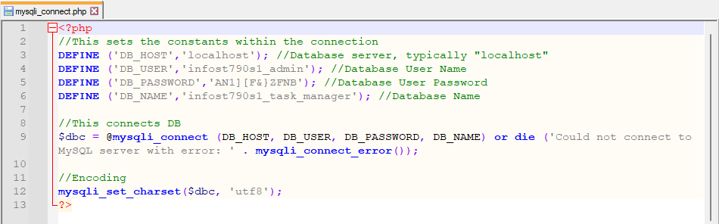

Style.css: Provides basic formatting to the pages.

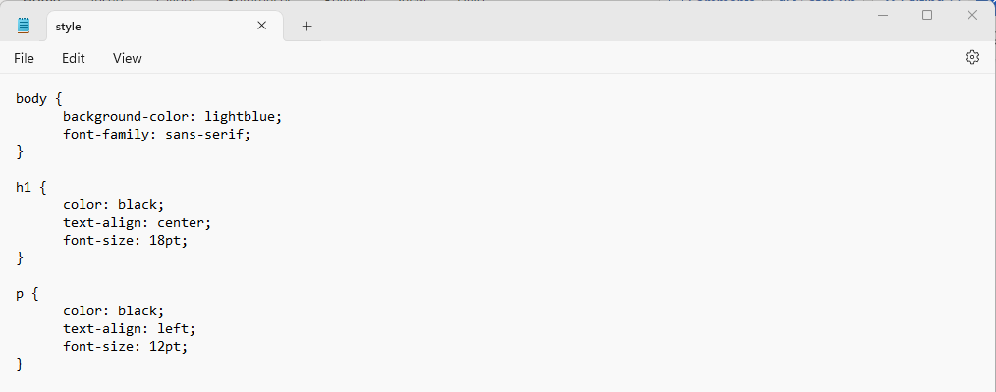

header.php: General header applied to pages once the user is logged in. This provides links to several other pages within the program.

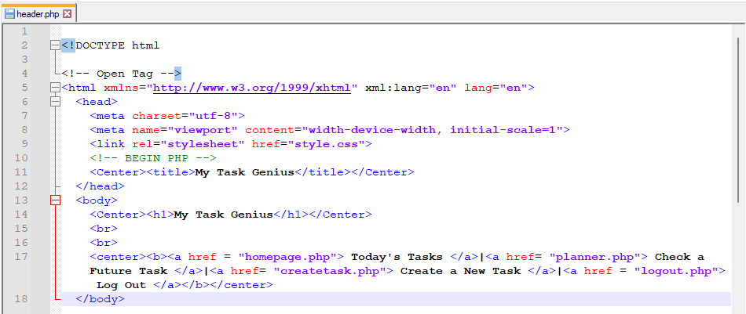

header2.php: General header for an individual who is not signed in. This provides links for account creation and to login.

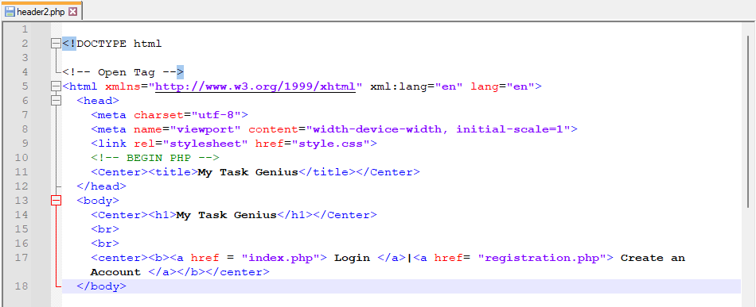

headeradmin.php: General header for when an individual is logged into an administrator account. Provides links to various administrator functions.

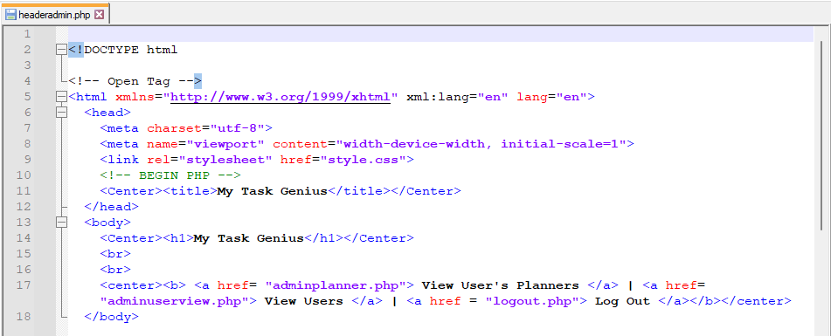

footer.php: Footer provided to all web pages.

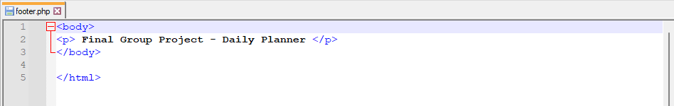

index.php: Acts as the login page for all users.

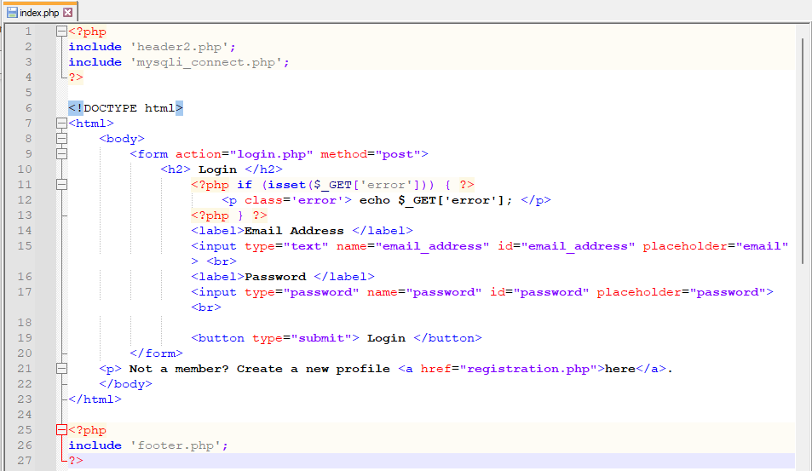

login.php: Passes login information from index.php to database and creates session.

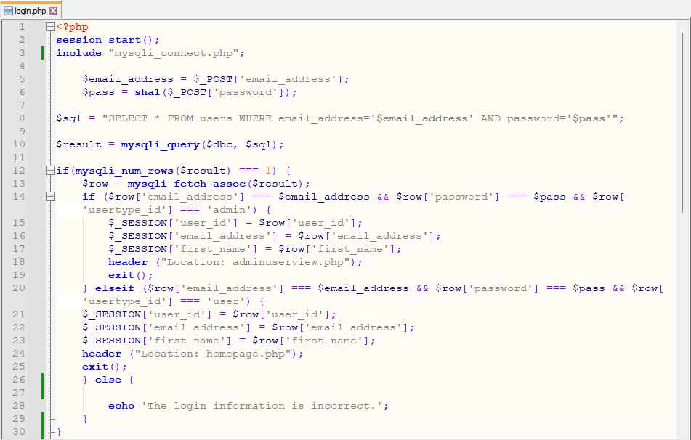

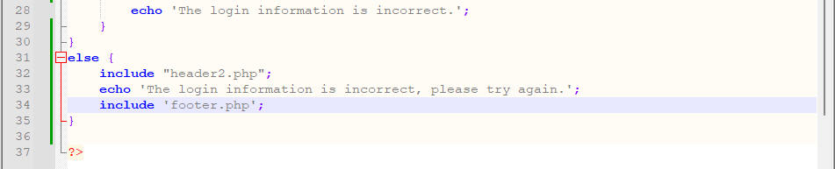

logout.php: Ends user session.

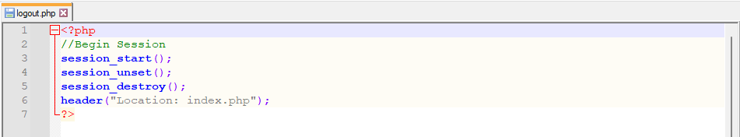

homepage.php: Acts as the homepage for users. Shows the current day’s tasks.

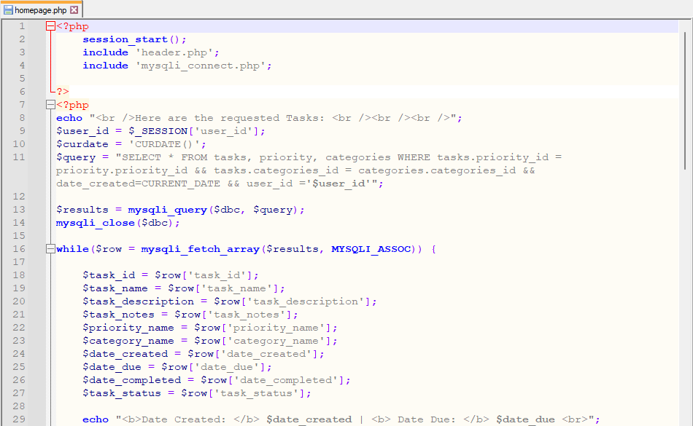

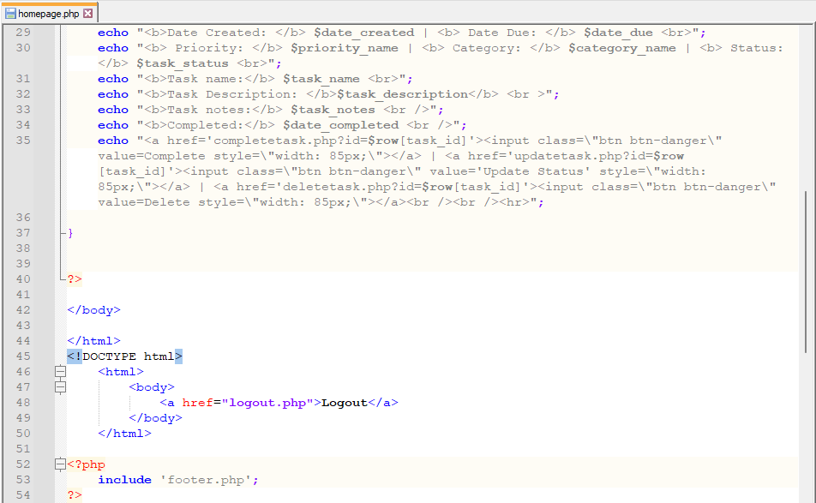

deletetask.php: Deletes the selected task.

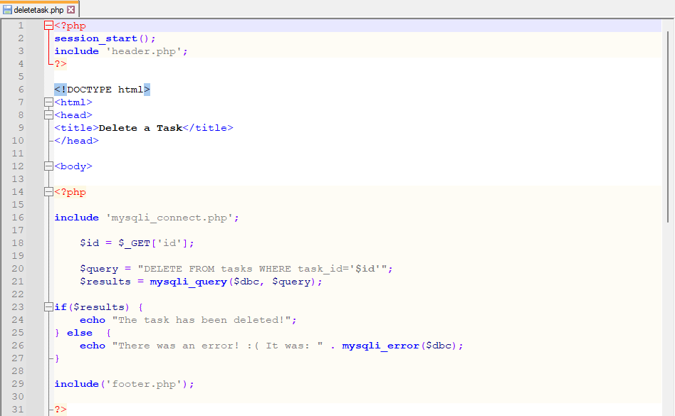

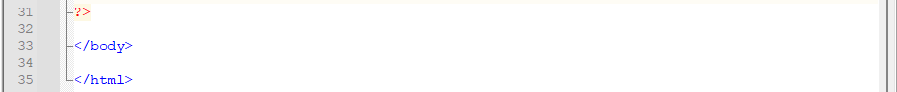

completetask.php: Adds the current date and time to the selected task completed field.

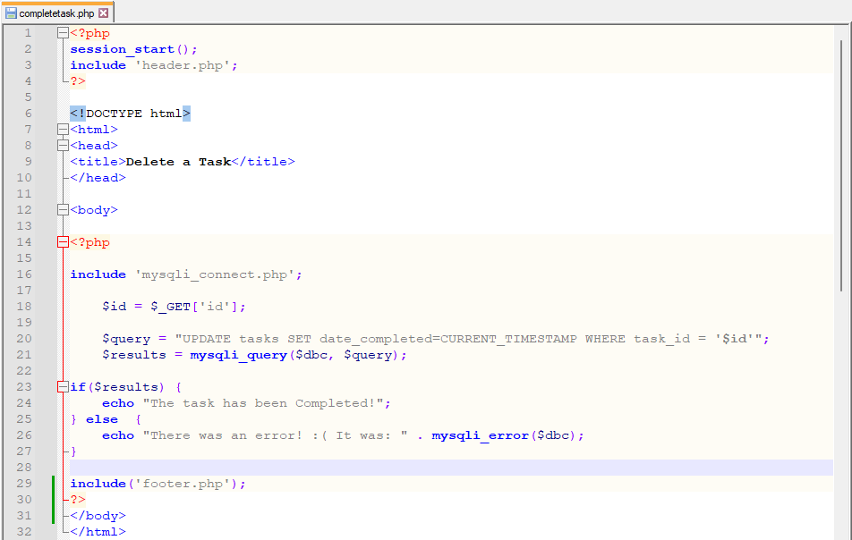

updatetask.php: Allows the user to update the status of the selected task.

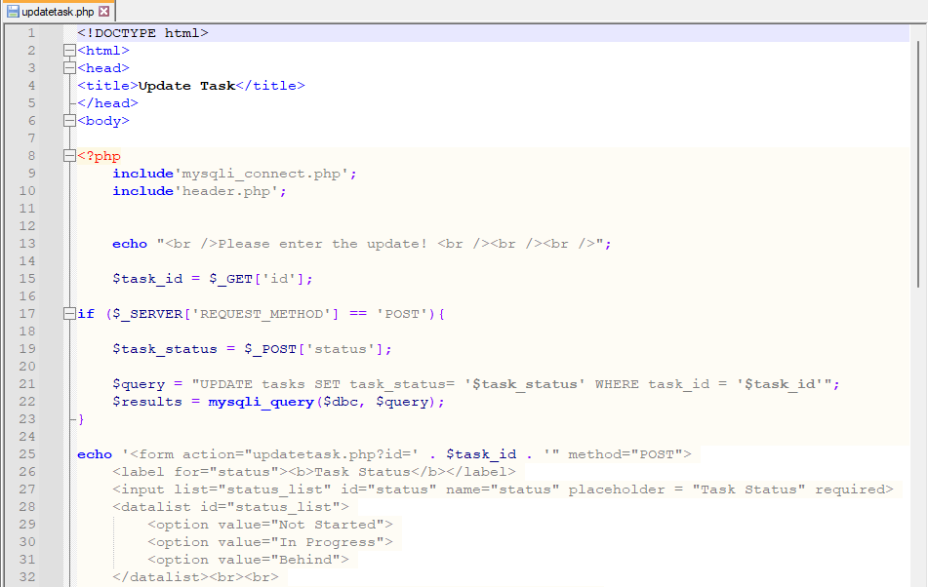

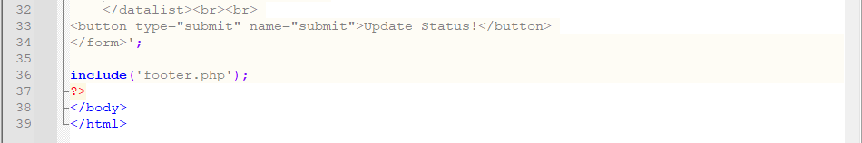

registration.php: Page to create a new user account.

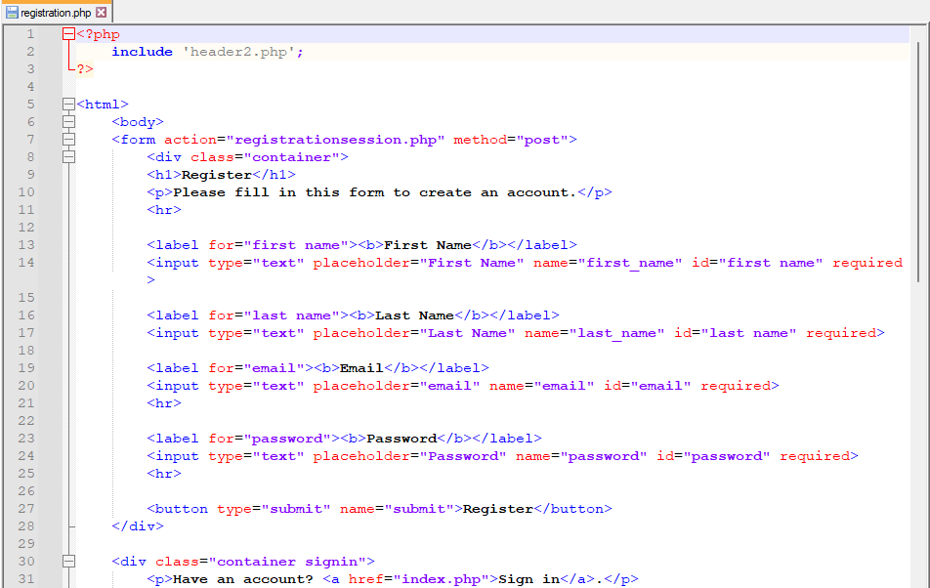

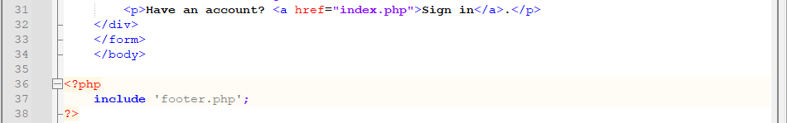

registrationsession.php: Passes information from registration.php to the database.

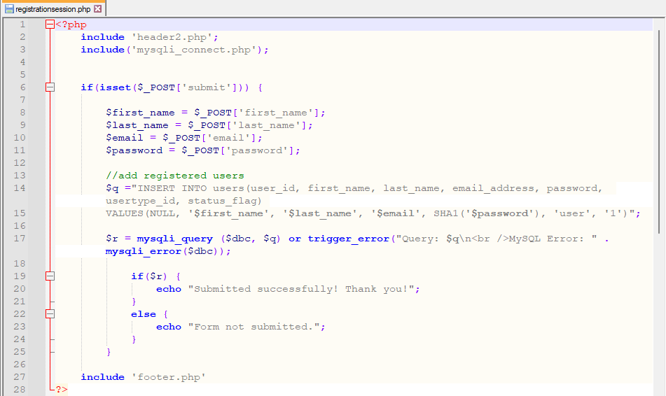

createtask.php: Requests information to create a new task.

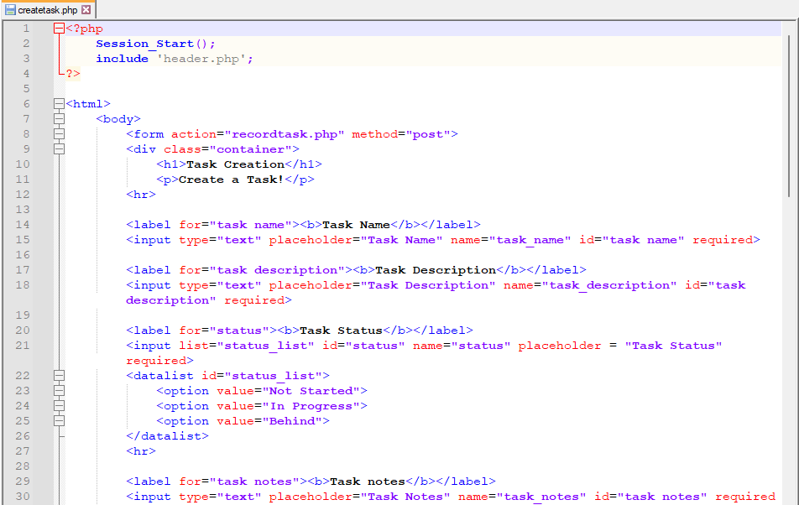

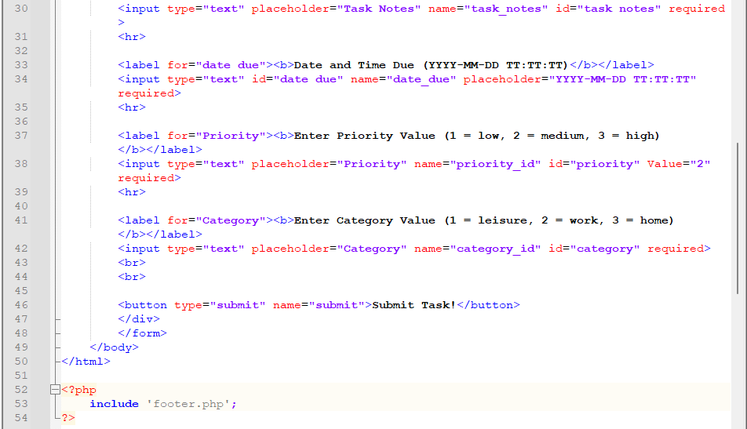

recordtask.php: Passes the information from createtask.php to the database.

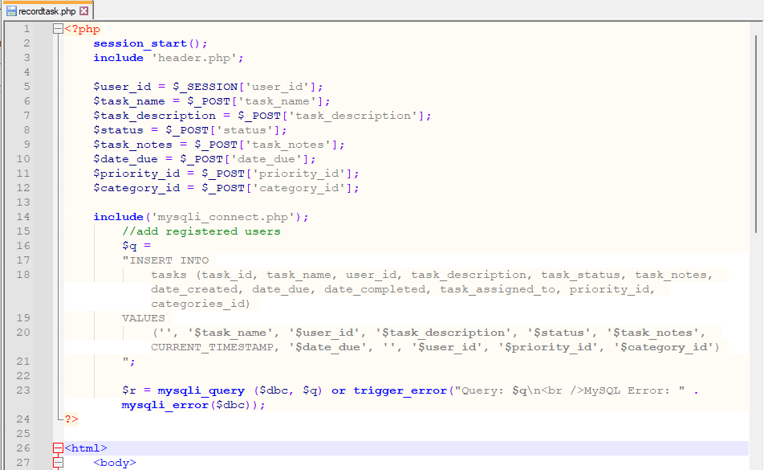

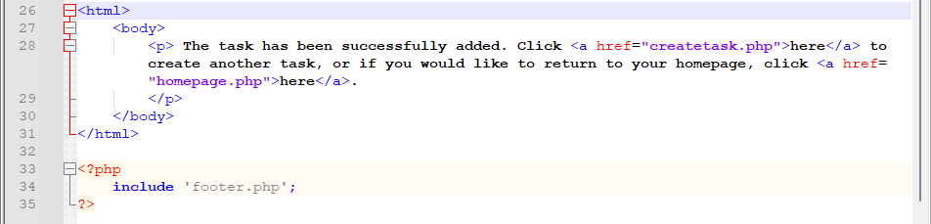

planner.php: Allows the user to enter a date and returns any tasks scheduled for that day.

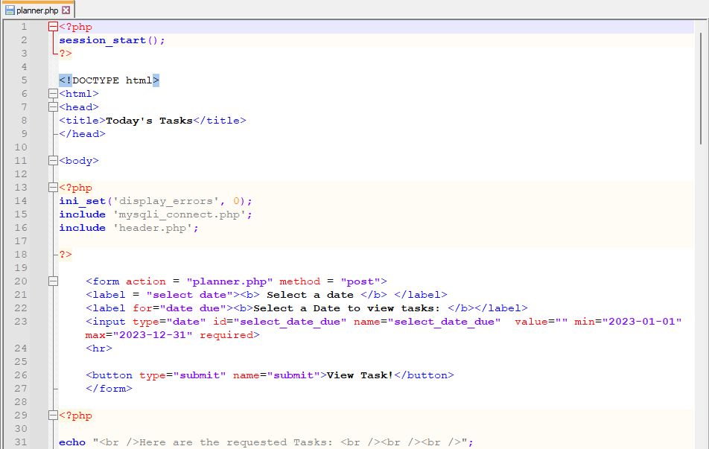

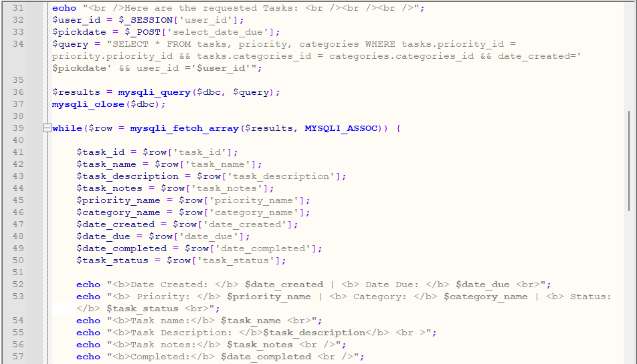

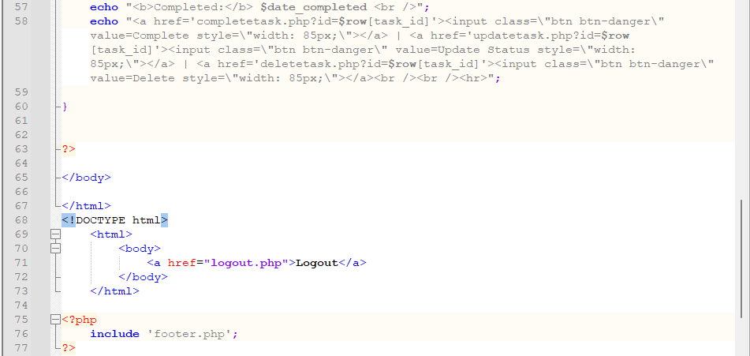

adminuserview.php: Administrator homepage, shows all of the users and information related to them.

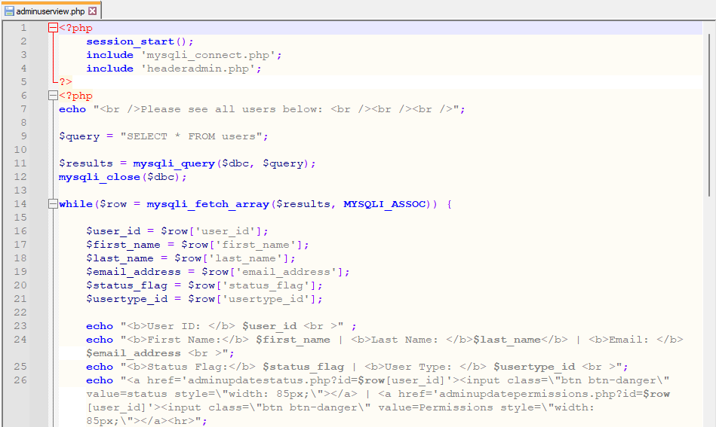

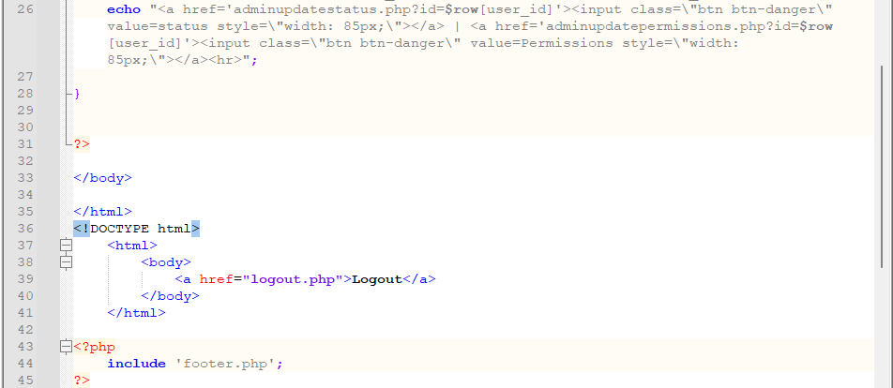

adminupdatepermissions.php: Allows an administrator to promote or demote another administrator.

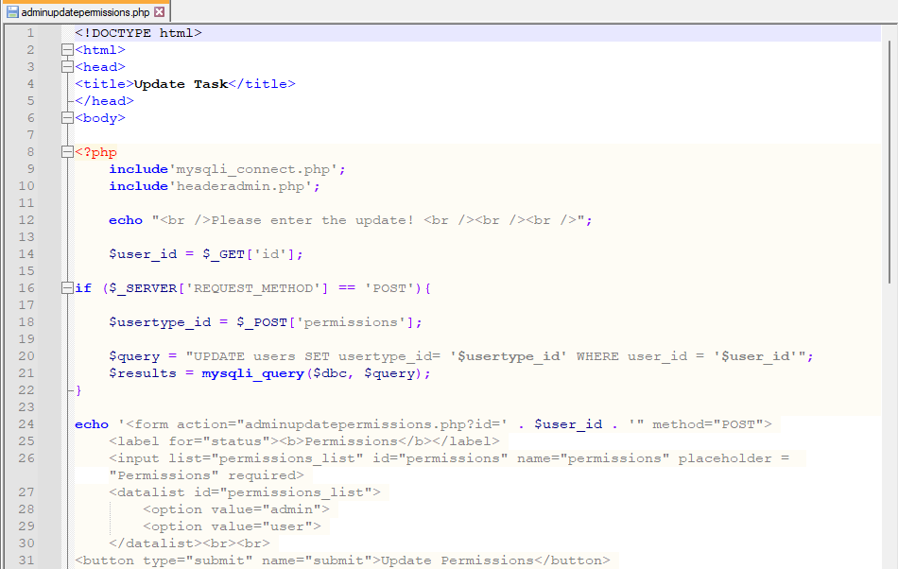

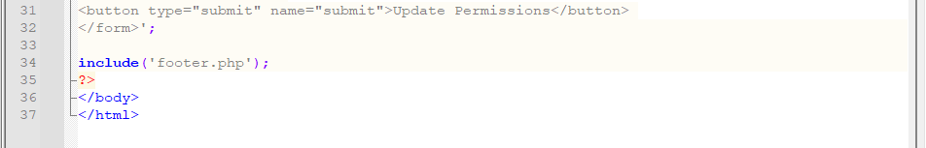

adminupdatestatus.php: Allows the administrator to mark a user account as active or inactive.

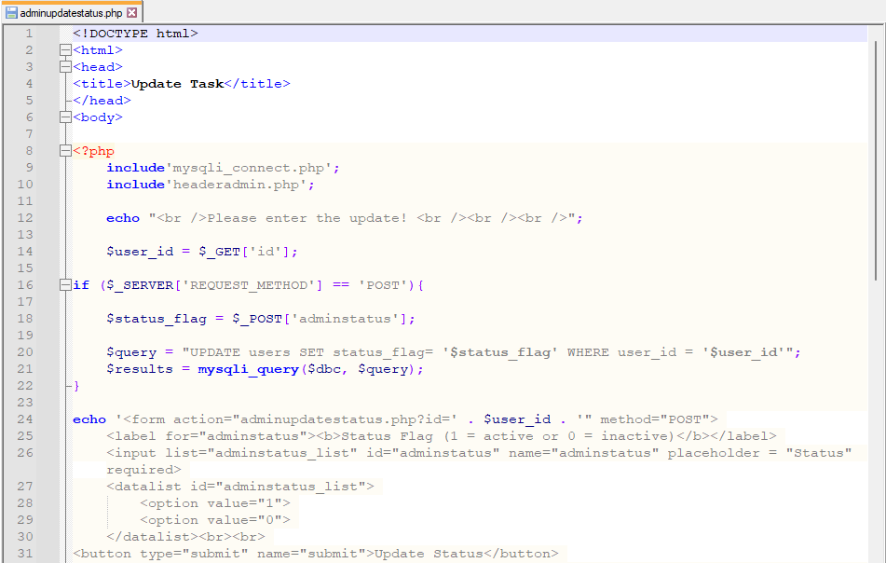

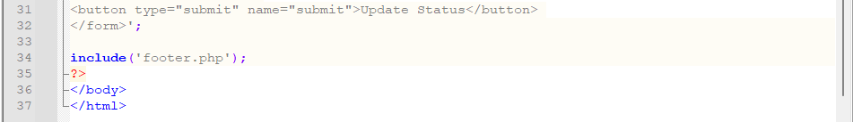

adminplanner.php: Allows the administrator to look up a specific user’s tasks by entering the User ID and Date.

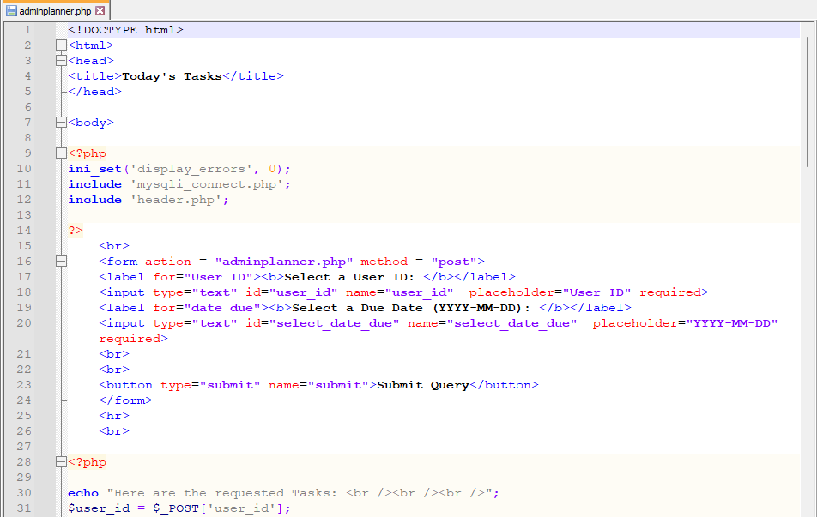

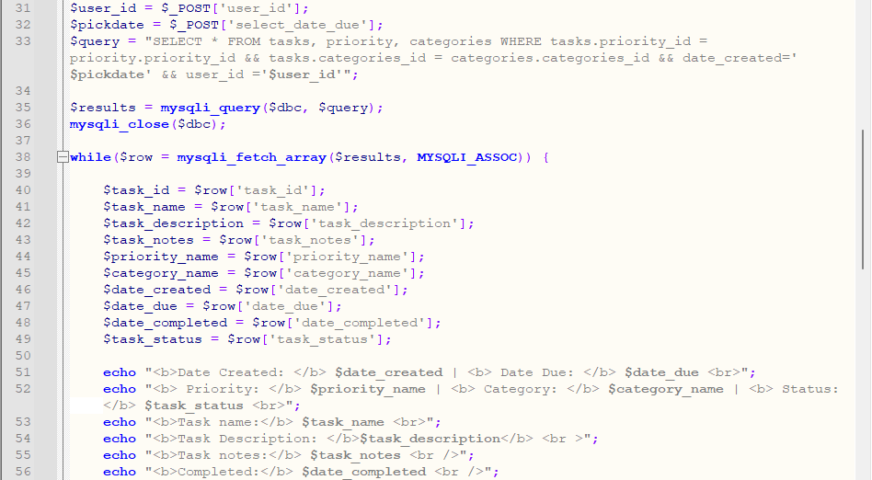

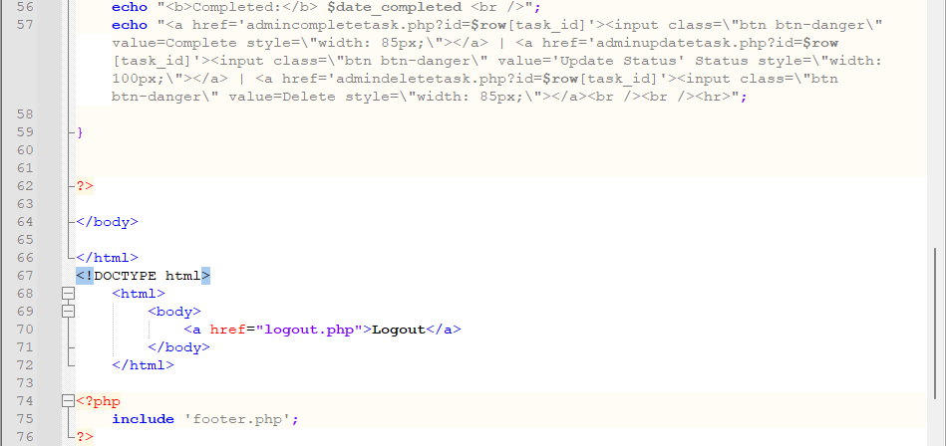

admindeletetask.php: Allows the administrator to delete the selected task.

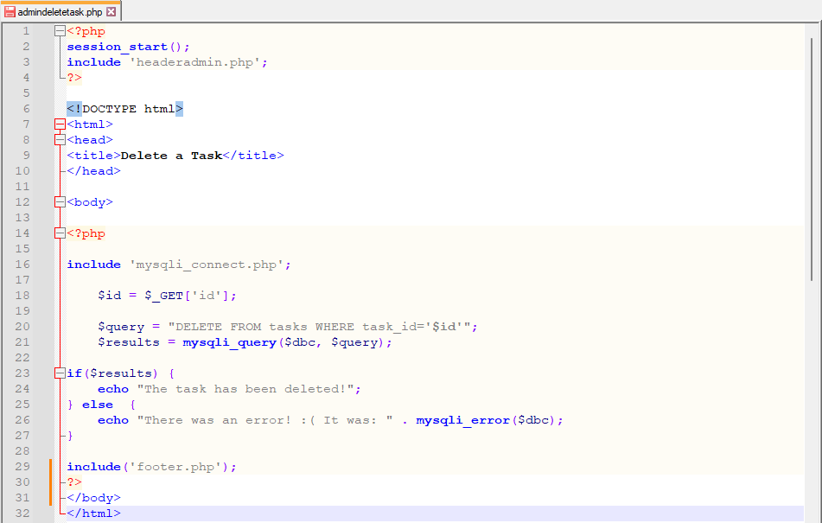

admincompletetask.php: Allows the administrator to mark the selected task as complete.

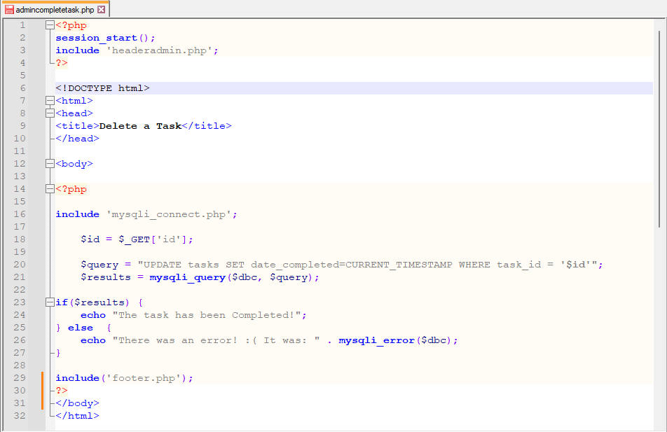

Adminupdatetask.php: Allows the administrator to update the status of the selected task.

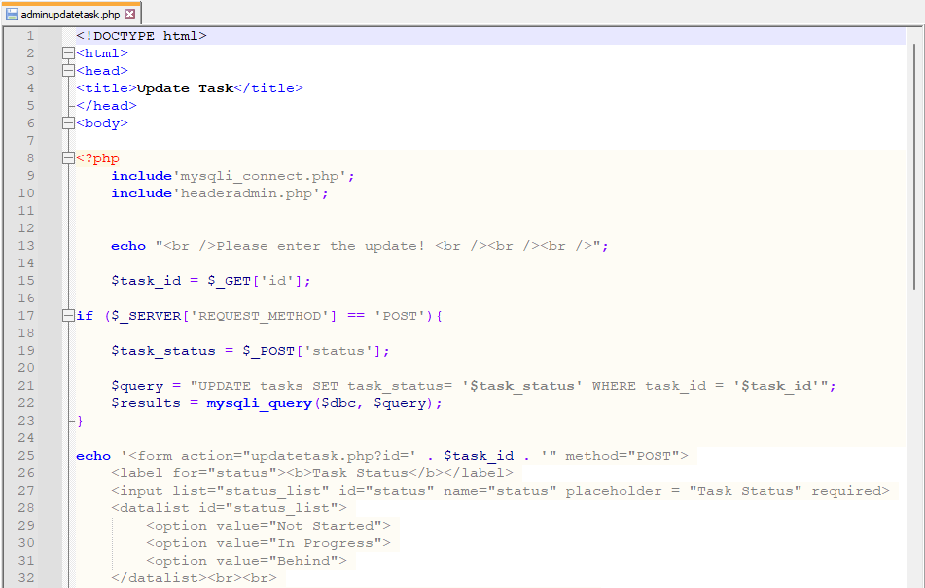

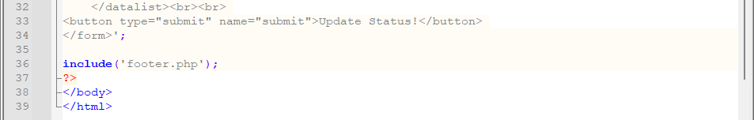

**Database Design**

1. Overview

The Task Genius website database is hosted on MySQL for maximum compatibility with PHP, the chosen web programming language for the site. It consists of four tables now with one-to-one relationships. In earlier designs it had 6 tables with a couple of one-to-many relationships. To focus on the main scope of the project a couple of tables were dropped because they did not fit the criteria of what we were trying to accomplish. The tables can be associated into two main focus areas. One is the Tasks and the other is the Users, with the other smaller tables (categories & priority) supporting both main tables. Only the main tables of Users and Tasks had auto-incrementing IDs that uniquely identifies each record in the tables. The tables utilize the INNODB engine so that foreign key relationships could be created to enforce referential integrity and overall data integrity throughout. The design is simple and flexible enough to support continuously changing business requirements.

The following section outlines the Entity-Relationship Diagram (ERD), a conceptual and representational model of data used to represent the entity framework infrastructure.

1. Entity-Relationship Diagram (ERD) 1:N Prototype #1

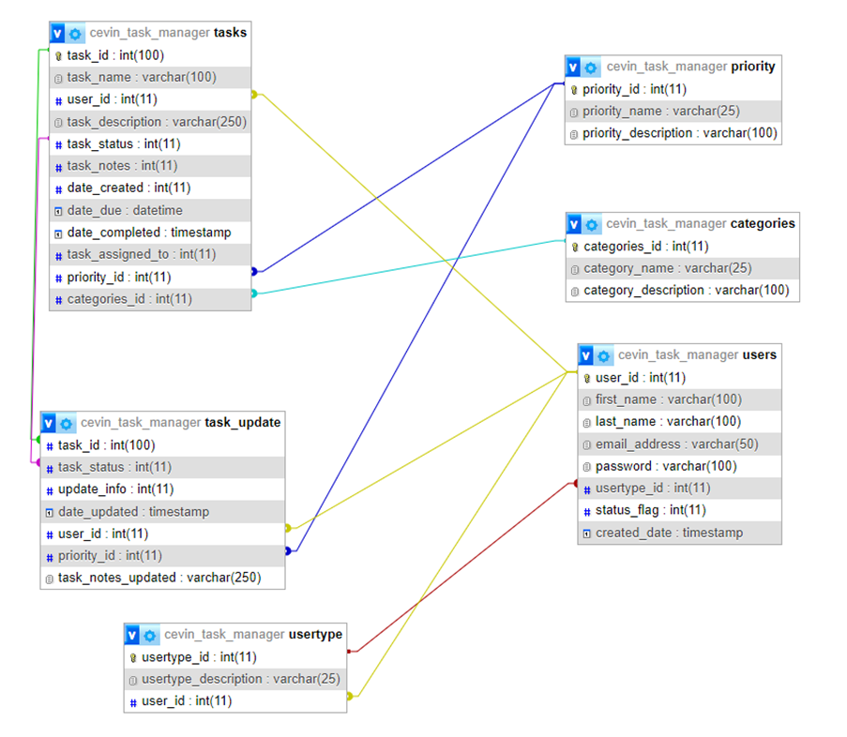

1. Entity-Relationship Diagram (ERD) 1:1 Prototype Final

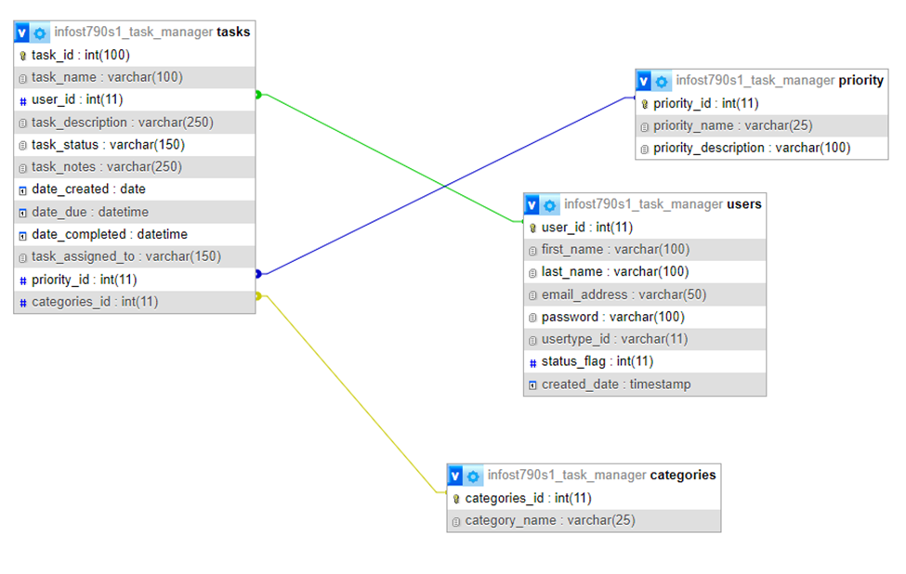

1. Data Definition Language (DDL)

Prototype #1 MYSQL code

--

-- Database: `cevin_task_manager`

--

--

-- Table structure for table `categories`

--

CREATE TABLE `categories` (

`categories_id` int(11) NOT NULL,

`category_name` varchar(25) NOT NULL,

`category_description` varchar(100) NOT NULL COMMENT 'leisure, work, home'

) ENGINE=InnoDB DEFAULT CHARSET=latin1;

-- --------------------------------------------------------

--

-- Table structure for table `priority`

--

CREATE TABLE `priority` (

`priority_id` int(11) NOT NULL DEFAULT '2' COMMENT '1=low 2=medium, 3=high',

`priority_name` varchar(25) NOT NULL COMMENT 'low, medium, high',

`priority_description` varchar(100) NOT NULL

) ENGINE=InnoDB DEFAULT CHARSET=latin1;

-- --------------------------------------------------------

--

-- Table structure for table `tasks`

--

CREATE TABLE `tasks` (

`task_id` int(100) NOT NULL,

`task_name` varchar(100) NOT NULL,

`user_id` int(11) NOT NULL,

`task_description` varchar(250) NOT NULL,

`task_status` int(11) NOT NULL,

`task_notes` int(11) NOT NULL,

`date_created` int(11) NOT NULL,

`date_due` datetime NOT NULL,

`date_completed` timestamp NOT NULL DEFAULT CURRENT_TIMESTAMP ON UPDATE CURRENT_TIMESTAMP,

`task_assigned_to` int(11) NOT NULL,

`priority_id` int(11) NOT NULL COMMENT '1=low,2=medium,3=high',

`categories_id` int(11) NOT NULL

) ENGINE=InnoDB DEFAULT CHARSET=latin1;

-- --------------------------------------------------------

--

-- Table structure for table `task_update`

--

CREATE TABLE `task_update` (

`task_id` int(100) NOT NULL,

`task_status` int(11) NOT NULL COMMENT 'In Progress, Behind, Not started',

`update_info` int(11) NOT NULL,

`date_updated` timestamp NOT NULL DEFAULT CURRENT_TIMESTAMP ON UPDATE CURRENT_TIMESTAMP,

`user_id` int(11) NOT NULL,

`priority_id` int(11) NOT NULL COMMENT '1=low 2=medium, 3=high',

`task_notes_updated` varchar(250) NOT NULL

) ENGINE=InnoDB DEFAULT CHARSET=latin1;

-- --------------------------------------------------------

--

-- Table structure for table `users`

--

CREATE TABLE `users` (

`user_id` int(11) NOT NULL,

`first_name` varchar(100) NOT NULL,

`last_name` varchar(100) NOT NULL,

`email_address` varchar(50) NOT NULL,

`password` varchar(100) NOT NULL,

`usertype_id` int(11) NOT NULL COMMENT 'admin or user',

`status_flag` int(11) NOT NULL COMMENT 'disabled or active',

`created_date` timestamp NOT NULL DEFAULT CURRENT_TIMESTAMP

) ENGINE=InnoDB DEFAULT CHARSET=latin1;

-- --------------------------------------------------------

--

-- Table structure for table `usertype`

--

CREATE TABLE `usertype` (

`usertype_id` int(11) NOT NULL,

`usertype_description` varchar(25) NOT NULL COMMENT 'admin or user',

`user_id` int(11) NOT NULL

) ENGINE=InnoDB DEFAULT CHARSET=latin1;

--

-- Indexes for dumped tables

--

--

-- Indexes for table `categories`

--

ALTER TABLE `categories`

ADD PRIMARY KEY (`categories_id`);

--

-- Indexes for table `priority`

--

ALTER TABLE `priority`

ADD PRIMARY KEY (`priority_id`);

--

-- Indexes for table `tasks`

--

ALTER TABLE `tasks`

ADD PRIMARY KEY (`task_id`),

ADD KEY `priority_id` (`priority_id`),

ADD KEY `categories_id` (`categories_id`),

ADD KEY `user_id` (`user_id`) USING BTREE,

ADD KEY `task_status` (`task_status`);

--

-- Indexes for table `task_update`

--

ALTER TABLE `task_update`

ADD KEY `task_id` (`task_id`),

ADD KEY `user_id` (`user_id`),

ADD KEY `priority_id` (`priority_id`),

ADD KEY `task_status` (`task_status`);

--

-- Indexes for table `users`

--

ALTER TABLE `users`

ADD PRIMARY KEY (`user_id`),

ADD KEY `usertype_id` (`usertype_id`);

--

-- Indexes for table `usertype`

--

ALTER TABLE `usertype`

ADD PRIMARY KEY (`usertype_id`),

ADD KEY `user_id` (`user_id`) USING BTREE,

ADD KEY `usertype_description` (`usertype_description`);

--

-- AUTO_INCREMENT for dumped tables

--

--

-- AUTO_INCREMENT for table `categories`

--

ALTER TABLE `categories`

MODIFY `categories_id` int(11) NOT NULL AUTO_INCREMENT;

--

-- AUTO_INCREMENT for table `tasks`

--

ALTER TABLE `tasks`

MODIFY `task_id` int(100) NOT NULL AUTO_INCREMENT;

--

-- AUTO_INCREMENT for table `users`

--

ALTER TABLE `users`

MODIFY `user_id` int(11) NOT NULL AUTO_INCREMENT;

--

-- AUTO_INCREMENT for table `usertype`

--

ALTER TABLE `usertype`

MODIFY `usertype_id` int(11) NOT NULL AUTO_INCREMENT;

--

-- Constraints for dumped tables

--

--

-- Constraints for table `tasks`

--

ALTER TABLE `tasks`

ADD CONSTRAINT `tasks_ibfk_1` FOREIGN KEY (`categories_id`) REFERENCES `categories` (`categories_id`) ON DELETE CASCADE ON UPDATE CASCADE,

ADD CONSTRAINT `tasks_ibfk_2` FOREIGN KEY (`priority_id`) REFERENCES `priority` (`priority_id`) ON DELETE CASCADE ON UPDATE CASCADE,

ADD CONSTRAINT `tasks_ibfk_3` FOREIGN KEY (`user_id`) REFERENCES `users` (`user_id`) ON DELETE CASCADE ON UPDATE CASCADE;

--

-- Constraints for table `task_update`

--

ALTER TABLE `task_update`

ADD CONSTRAINT `task_update_ibfk_1` FOREIGN KEY (`task_id`) REFERENCES `tasks` (`task_id`) ON DELETE CASCADE ON UPDATE CASCADE,

ADD CONSTRAINT `task_update_ibfk_2` FOREIGN KEY (`priority_id`) REFERENCES `priority` (`priority_id`) ON DELETE CASCADE ON UPDATE CASCADE,

ADD CONSTRAINT `task_update_ibfk_3` FOREIGN KEY (`user_id`) REFERENCES `users` (`user_id`) ON DELETE CASCADE ON UPDATE CASCADE,

ADD CONSTRAINT `task_update_ibfk_4` FOREIGN KEY (`task_status`) REFERENCES `tasks` (`task_status`);

--

-- Constraints for table `users`

--

ALTER TABLE `users`

ADD CONSTRAINT `users_ibfk_1` FOREIGN KEY (`usertype_id`) REFERENCES `usertype` (`usertype_id`) ON DELETE CASCADE ON UPDATE CASCADE;

--

-- Constraints for table `usertype`

--

ALTER TABLE `usertype`

ADD CONSTRAINT `usertype_ibfk_1` FOREIGN KEY (`user_id`) REFERENCES `users` (`user_id`) ON DELETE CASCADE ON UPDATE CASCADE;

COMMIT;

Prototype Final MYSQL code

--

-- Database: `infost790s1_task_manager`

--

-- --------------------------------------------------------

--

-- Table structure for table `categories`

--

CREATE TABLE `categories` (

`categories_id` int(11) NOT NULL,

`category_name` varchar(25) NOT NULL

) ENGINE=InnoDB DEFAULT CHARSET=latin1;

--

-- Dumping data for table `categories`

--

INSERT INTO `categories` (`categories_id`, `category_name`) VALUES

(1, 'leisure'),

(2, 'work'),

(3, 'home');

-- --------------------------------------------------------

--

-- Table structure for table `priority`

--

CREATE TABLE `priority` (

`priority_id` int(11) NOT NULL DEFAULT '2' COMMENT '1=low 2=medium, 3=high',

`priority_name` varchar(25) NOT NULL COMMENT 'low, medium, high',

`priority_description` varchar(100) NOT NULL

) ENGINE=InnoDB DEFAULT CHARSET=latin1;

--

-- Dumping data for table `priority`

--

INSERT INTO `priority` (`priority_id`, `priority_name`, `priority_description`) VALUES

(1, 'low', ''),

(2, 'medium', ''),

(3, 'high', '');

-- --------------------------------------------------------

--

-- Table structure for table `tasks`

--

CREATE TABLE `tasks` (

`task_id` int(100) NOT NULL,

`task_name` varchar(100) NOT NULL,

`user_id` int(11) NOT NULL,

`task_description` varchar(250) NOT NULL,

`task_status` varchar(150) NOT NULL COMMENT 'In Progress, Behind, Not started',

`task_notes` varchar(250) NOT NULL,

`date_created` date NOT NULL,

`date_due` datetime NOT NULL,

`date_completed` datetime DEFAULT CURRENT_TIMESTAMP,

`task_assigned_to` varchar(150) NOT NULL COMMENT 'name assigned to',

`priority_id` int(11) NOT NULL COMMENT '1=low,2=medium,3=high',

`categories_id` int(11) NOT NULL COMMENT 'Is this needed?'

) ENGINE=InnoDB DEFAULT CHARSET=latin1;

--

-- Dumping data for table `tasks`

--

INSERT INTO `tasks` (`task_id`, `task_name`, `user_id`, `task_description`, `task_status`, `task_notes`, `date_created`, `date_due`, `date_completed`, `task_assigned_to`, `priority_id`, `categories_id`) VALUES

(17, 'test', 1, 'test', 'In Progress', '', '2023-04-28', '0000-00-00 00:00:00', '2023-04-28 18:57:43', '1', 1, 1),

(18, 'test2', 1, 'test2', 'In Progress', '', '2023-04-28', '2023-04-29 00:00:00', '2023-04-28 21:55:00', '1', 1, 1),

(19, 'test task1', 1, 'This is a test', 'Not Started', 'This is a test', '2023-04-29', '2023-04-29 00:00:00', '0000-00-00 00:00:00', '1', 1, 1),

(20, 'test task2', 1, 'This is a test', 'Not Started', 'This is a test', '2023-04-29', '2023-04-29 00:00:00', '0000-00-00 00:00:00', '1', 1, 1),

(26, '', 12, 'Another test task', 'In Progress', 'Wow such test', '2023-04-29', '2023-04-30 07:30:00', '2023-04-29 20:51:14', '12', 2, 3),

(28, '04/30 test', 12, 'test task', 'Not Started', 'test', '2023-04-30', '2023-04-30 07:30:00', '0000-00-00 00:00:00', '12', 2, 3);

-- --------------------------------------------------------

--

-- Table structure for table `users`

--

CREATE TABLE `users` (

`user_id` int(11) NOT NULL,

`first_name` varchar(100) NOT NULL,

`last_name` varchar(100) NOT NULL,

`email_address` varchar(50) NOT NULL,

`password` varchar(100) NOT NULL,

`usertype_id` varchar(11) NOT NULL COMMENT 'admin or user',

`status_flag` int(11) NOT NULL COMMENT '1=active 0=inactive ',

`created_date` timestamp NOT NULL DEFAULT CURRENT_TIMESTAMP

) ENGINE=InnoDB DEFAULT CHARSET=latin1;

--

-- Dumping data for table `users`

--

INSERT INTO `users` (`user_id`, `first_name`, `last_name`, `email_address`, `password`, `usertype_id`, `status_flag`, `created_date`) VALUES

(1, 'admin', '', 'admin', 'd033e22ae348aeb5660fc2140aec35850c4da997', 'admin', 1, '2023-04-22 04:08:11'),

(2, 'Bridgette', 'Antonat', '[bantonat1@mediafire.com](mailto:bantonat1@mediafire.com)', 'ac92fb8b3e0275f9415836badcab3ae7068ec031', 'user', 1, '2023-02-04 06:00:00'),

(3, 'Smitty', 'Kelloway', '[skelloway2@google.ru](mailto:skelloway2@google.ru)', '62926f9f584838a1cf6953aff4244e67e68254dc', 'user', 1, '2023-03-03 06:00:00'),

(4, 'Corene', 'Paintain', '[cpaintain3@xinhuanet.com](mailto:cpaintain3@xinhuanet.com)', 'de7d41b60611d47e82a4d72111fe9875ed5d5083', 'user', 1, '2023-03-31 05:00:00'),

(5, 'Serene', 'Grelak', '[sgrelak4@springer.com](mailto:sgrelak4@springer.com)', '0bb4e633d813cd1fa18f133464077472920a1f96', 'user', 0, '2023-03-12 06:00:00'),

(6, 'Barbaraanne', 'Wand', '[bwand5@instagram.com](mailto:bwand5@instagram.com)', '4ea55462111b3de4e97496e55c83232d0bd1400f', 'user', 1, '2023-03-11 06:00:00'),

(7, 'Tom', 'Baker', '[tom@uwm.com](mailto:tom@uwm.com)', '5baa61e4c9b93f3f0682250b6cf8331b7ee68fd8', 'user', 1, '2023-04-22 04:15:02'),

(8, 'Holly', 'Cricket', '[hcricket6@nbcnews.com](mailto:hcricket6@nbcnews.com)', 'd672ca8c3151d2f0897fa011265df6efd1b49b1e', 'user', 0, '2023-02-15 06:00:00'),

(9, 'Gennie', 'Mougeot', '[gmougeot7@vimeo.com](mailto:gmougeot7@vimeo.com)', '5e754d2a4c6a473028026ff79a9ed0c61e781d42', 'user', 1, '2023-02-15 06:00:00'),

(10, 'Dorey', 'Pettie', '[dpettie8@cam.ac.uk](mailto:dpettie8@cam.ac.uk)', 'bd3bbfb29404471baa354b62355f9e9f54176401', 'user', 1, '2023-04-01 05:00:00'),

(11, 'Tersina', 'Seath', '[tseath9@artisteer.com](mailto:tseath9@artisteer.com)', '10b2eb76749cd414cb4f2da446e1f4932390d822', 'user', 0, '2023-04-07 05:00:00'),

(12, 'Andrew', 'Lukowski', 'test', 'a94a8fe5ccb19ba61c4c0873d391e987982fbbd3', 'user', 1, '2023-04-26 22:45:48'),

(13, 'Andrew', 'Lukowski', 'test2', 'a94a8fe5ccb19ba61c4c0873d391e987982fbbd3', 'user', 1, '2023-04-29 12:48:27'),

(14, 'Cassandra', 'Franco', '[clfranco@uwm.edu](mailto:clfranco@uwm.edu)', 'd7cd56f2a2a3f47830760edfb89946eb7b9e2cd1', 'user', 1, '2023-04-30 18:15:05'),

(15, 'Andrew', 'Lukowski', '[lukowsk2@uwm.edu](mailto:lukowsk2@uwm.edu)', '9d4e1e23bd5b727046a9e3b4b7db57bd8d6ee684', 'user', 1, '2023-04-30 18:20:15');

--

-- Indexes for dumped tables

--

--

-- Indexes for table `categories`

--

ALTER TABLE `categories`

ADD PRIMARY KEY (`categories_id`);

--

-- Indexes for table `priority`

--

ALTER TABLE `priority`

ADD PRIMARY KEY (`priority_id`);

--

-- Indexes for table `tasks`

--

ALTER TABLE `tasks`

ADD PRIMARY KEY (`task_id`),

ADD KEY `priority_id` (`priority_id`),

ADD KEY `categories_id` (`categories_id`),

ADD KEY `user_id` (`user_id`) USING BTREE;

--

-- Indexes for table `users`

--

ALTER TABLE `users`

ADD PRIMARY KEY (`user_id`);

--

-- AUTO_INCREMENT for dumped tables

--

--

-- AUTO_INCREMENT for table `categories`

--

ALTER TABLE `categories`

MODIFY `categories_id` int(11) NOT NULL AUTO_INCREMENT, AUTO_INCREMENT=4;

--

-- AUTO_INCREMENT for table `tasks`

--

ALTER TABLE `tasks`

MODIFY `task_id` int(100) NOT NULL AUTO_INCREMENT, AUTO_INCREMENT=29;

--

-- AUTO_INCREMENT for table `users`

--

ALTER TABLE `users`

MODIFY `user_id` int(11) NOT NULL AUTO_INCREMENT, AUTO_INCREMENT=16;

--

-- Constraints for dumped tables

--

--

-- Constraints for table `tasks`

--

ALTER TABLE `tasks`

ADD CONSTRAINT `tasks_ibfk_3` FOREIGN KEY (`user_id`) REFERENCES `users` (`user_id`) ON DELETE CASCADE ON UPDATE CASCADE,

ADD CONSTRAINT `tasks_ibfk_4` FOREIGN KEY (`priority_id`) REFERENCES `priority` (`priority_id`) ON DELETE CASCADE ON UPDATE CASCADE,

ADD CONSTRAINT `tasks_ibfk_5` FOREIGN KEY (`categories_id`) REFERENCES `categories` (`categories_id`) ON DELETE CASCADE ON UPDATE CASCADE;

COMMIT;

Encrypted pre-existing passwords on database.

[UPDATE](https://uwmsois.com:2083/cpsess0010462897/3rdparty/phpMyAdmin/url.php?url=https://dev.mysql.com/doc/refman/5.7/en/update.html) `users` [SET](https://uwmsois.com:2083/cpsess0010462897/3rdparty/phpMyAdmin/url.php?url=https://dev.mysql.com/doc/refman/5.7/en/set.html) `password` = SHA1('i8Ai4mjM9NZi') WHERE `users`.`user_id` = 2; [UPDATE](https://uwmsois.com:2083/cpsess0010462897/3rdparty/phpMyAdmin/url.php?url=https://dev.mysql.com/doc/refman/5.7/en/update.html) `users` [SET](https://uwmsois.com:2083/cpsess0010462897/3rdparty/phpMyAdmin/url.php?url=https://dev.mysql.com/doc/refman/5.7/en/set.html) `password` = SHA1('VaZGWG') WHERE `users`.`user_id` = 3; [UPDATE](https://uwmsois.com:2083/cpsess0010462897/3rdparty/phpMyAdmin/url.php?url=https://dev.mysql.com/doc/refman/5.7/en/update.html) `users` [SET](https://uwmsois.com:2083/cpsess0010462897/3rdparty/phpMyAdmin/url.php?url=https://dev.mysql.com/doc/refman/5.7/en/set.html) `password` = SHA1('Rx5arhDXF') WHERE `users`.`user_id` = 4; [UPDATE](https://uwmsois.com:2083/cpsess0010462897/3rdparty/phpMyAdmin/url.php?url=https://dev.mysql.com/doc/refman/5.7/en/update.html) `users` [SET](https://uwmsois.com:2083/cpsess0010462897/3rdparty/phpMyAdmin/url.php?url=https://dev.mysql.com/doc/refman/5.7/en/set.html) `password` = SHA1('gVb9gV') WHERE `users`.`user_id` = 5; [UPDATE](https://uwmsois.com:2083/cpsess0010462897/3rdparty/phpMyAdmin/url.php?url=https://dev.mysql.com/doc/refman/5.7/en/update.html) `users` [SET](https://uwmsois.com:2083/cpsess0010462897/3rdparty/phpMyAdmin/url.php?url=https://dev.mysql.com/doc/refman/5.7/en/set.html) `password` = SHA1('2ttWEDfm') WHERE `users`.`user_id` = 6; [UPDATE](https://uwmsois.com:2083/cpsess0010462897/3rdparty/phpMyAdmin/url.php?url=https://dev.mysql.com/doc/refman/5.7/en/update.html) `users` [SET](https://uwmsois.com:2083/cpsess0010462897/3rdparty/phpMyAdmin/url.php?url=https://dev.mysql.com/doc/refman/5.7/en/set.html) `password` = SHA1('password') WHERE `users`.`user_id` = 7; [UPDATE](https://uwmsois.com:2083/cpsess0010462897/3rdparty/phpMyAdmin/url.php?url=https://dev.mysql.com/doc/refman/5.7/en/update.html) `users` [SET](https://uwmsois.com:2083/cpsess0010462897/3rdparty/phpMyAdmin/url.php?url=https://dev.mysql.com/doc/refman/5.7/en/set.html) `password` = SHA1('kZpeRbJYi3r') WHERE `users`.`user_id` = 8; [UPDATE](https://uwmsois.com:2083/cpsess0010462897/3rdparty/phpMyAdmin/url.php?url=https://dev.mysql.com/doc/refman/5.7/en/update.html) `users` [SET](https://uwmsois.com:2083/cpsess0010462897/3rdparty/phpMyAdmin/url.php?url=https://dev.mysql.com/doc/refman/5.7/en/set.html) `password` = SHA1('XPWEJ4ZIh') WHERE `users`.`user_id` = 9; [UPDATE](https://uwmsois.com:2083/cpsess0010462897/3rdparty/phpMyAdmin/url.php?url=https://dev.mysql.com/doc/refman/5.7/en/update.html) `users` [SET](https://uwmsois.com:2083/cpsess0010462897/3rdparty/phpMyAdmin/url.php?url=https://dev.mysql.com/doc/refman/5.7/en/set.html) `password` = SHA1('Jyisyob1') WHERE `users`.`user_id` = 10; [UPDATE](https://uwmsois.com:2083/cpsess0010462897/3rdparty/phpMyAdmin/url.php?url=https://dev.mysql.com/doc/refman/5.7/en/update.html) `users` [SET](https://uwmsois.com:2083/cpsess0010462897/3rdparty/phpMyAdmin/url.php?url=https://dev.mysql.com/doc/refman/5.7/en/set.html) `password` = SHA1('8RuDcE') WHERE `users`.`user_id` = 11;

1. **MySQL Information**

The following section outlines the table schemas which give the values in a column, constraints on the value, and the expected format of the data, stored procedures which the website uses to provide scheduling information, and the Data Definition Language (DDL) which creates the tables and the relationships between them.

**Table Schemas**

“tasks” Table

|  |  |  |  |  |  |
| --- | --- | --- | --- | --- | --- |
| Key | Fieldname | Datatype | Length | Optional | Other |
| PK | task_id | int | 100 | N | auto_increment |
|  | task_name | varchar | 100 | N |  |
| FK | user_id | int | 11 | N |  |
|  | task_description | varchar | 250 | N |  |
|  | task_staus | varchar | 150 | N | In Progress, Behind, Not Started |
|  | task_notes | varchar | 250 | N |  |
|  | date_created | date |  | N |  |
|  | date_due | datetime |  | N |  |
|  | date_completed | datetime |  | Y | CURRENT_TIMESTAMP |
|  | task_assigned_to | varchar | 150 | N | Name assigned to |
| FK | priority_id | int | 11 | N | 1=low,2=medium,3=high |
| FK | categories_id | int | 11 | N |  |

“users” Table

|  |  |  |  |  |  |
| --- | --- | --- | --- | --- | --- |
| Key | Fieldname | Datatype | Length | Optional | Comments/Other |
| PK | user_id | int | 11 | N | auto_increment |
|  | first_name | varchar | 100 | N |  |
|  | last_name | varchar | 100 | N |  |
|  | email_address | varchar | 50 | N |  |
|  | password | varchar | 100 | N |  |
|  | usertype_id | varchar | 11 | N | Admin or user |
|  | status_flag | int | 11 | N | 1=active 0-inactive |
|  | created_date | timestamp |  | N | CURRENT_TIMESTAMP |

“priority” Table

|  |  |  |  |  |  |
| --- | --- | --- | --- | --- | --- |
| Key | Fieldname | Datatype | Length | Optional | Other |
| PK | priority_id | int | 11 | N | 1=low,2=medium,3=high |
|  | priority_name | varchar | 25 | N | low, medium, high |
|  | priority_description | varchar | 100 | N |  |

“categories” Table

|  |  |  |  |  |  |
| --- | --- | --- | --- | --- | --- |
| Key | Fieldname | Datatype | Length | Optional | Other |
| PK | user_id | int | 11 | N | auto_increment |
|  | first_name | varchar | 25 | N |  |

**Network Diagram**

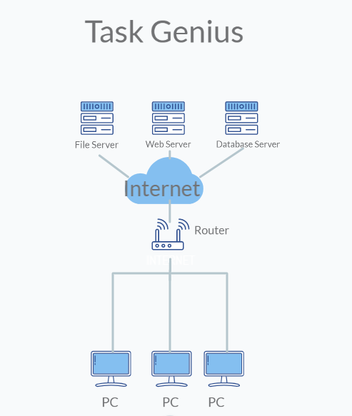

**Conclusion:**

In conclusion, the personal task manager prototype is a web-based application that helps users manage their daily tasks and events. The system is designed using modern web development tools and technologies and follows the Model-View-Controller architecture. The system's functionality includes the ability to create, edit, and delete tasks and events, set task priorities, reminders, and due dates, and search for specific tasks and events.